**Australian Professional Snowsport Instructors (APSI)**



**Creating Versatile Teachers**

The APSI on-snow teaching workshop at Interski 2019 aims to share how we train snowsports instructors to be versatile in teaching our Australian guests. Across the Australian resorts and international destinations worked at in the Northern seasons, APSI instructors strive to adapt to any situation they are presented with. The need to be versatile comes from the many variables we encounter in a typical day to day lesson.

The Australian Snowsports environment and industry is certainly a unique place. Some of the variables faced during a classic Aussie lesson are no different to those faced around the globe. We do, however, experience higher than average levels of the following situations which shape the way we teach and adapt on a day to day basis as a snowsport instructor.

* **Harsh conditions**. Teaching in the Australian mountains can be unpredictable and changes from one hour to the next. It may sometimes include lower than average snow fall, rainy and windy days, very hot spring months and changing snow conditions from powder, slush, ice or firm all in one day.
* **Our Australian guests**. Come from far and wide to get to the resorts which are in a remote, rural part of the country. We see a large variance in physical and cultural attributes amongst our guests from athletic vs non-athletic, different learning styles and many different nationalities and cultures. The students in our lessons have very different backgrounds and are often first timers to the sport. There is usually a high volume of guest’s vs skiable hectares of terrain.
* **Lesson structure**. In general we see shorter lessons that may have 10-15 people per group. Resorts have a larger focus on group lessons. Some instructors may teach up to 5 lessons in 1 day.

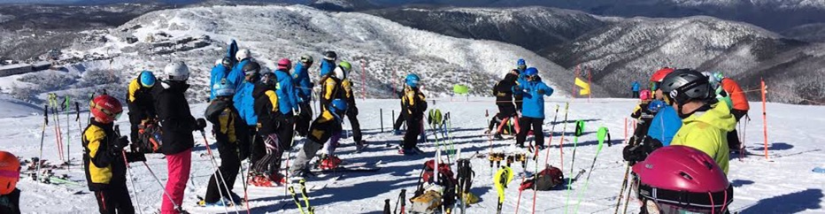

Our on-snow presentation will focus on 3 key principles that our instructors use every day to deliver a versatile product and an ever changing experience to their guests to combat some of these variables/challenges.

1. **New fundamental mechanics**
2. **Creativity and Adaptability**
3. **What, Why and How**

**New Fundamental Mechanics**

Every new situation, turn type or task that a student may want to accomplish as a goal, requires them to gain new knowledge, skills or tactics that they will need to add to what is already known. Once these ‘New Fundamental Mechanics’ are added to the students previous skill set or knowledge, it will help them   
on the journey to achieving the task or goal they have in mind.

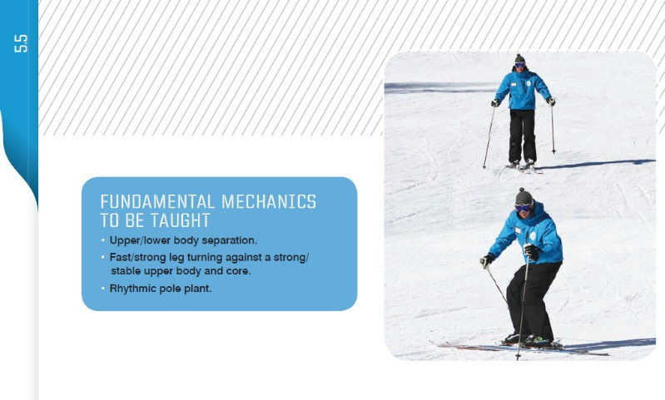For example, a skier that can already do a basic parallel turn and is wanting to ski a short turn for the first time will need to change some of their mechanics/movements to achieve the faster rhythm and shorter turn shape they are seeking. We believe the skier will need to add some of the following new movements to their basic parallel turns to shorten the radius:

* Fast/strong leg turning against a stable upper body
* Upper/lower body separation
* Faster/Rhythmical pole plant.

Knowing these ‘new fundamental mechanics’ provides the instructor with a framework or guide to build their lesson plan around. They can start out their lessons with these points in mind to help work towards their student’s desired goal. Of course there will be problems encountered along the way and other skills, mechanics or tactics not listed above will need addressing, but at least it provides a starting point and structure for the instructor and student to work towards.

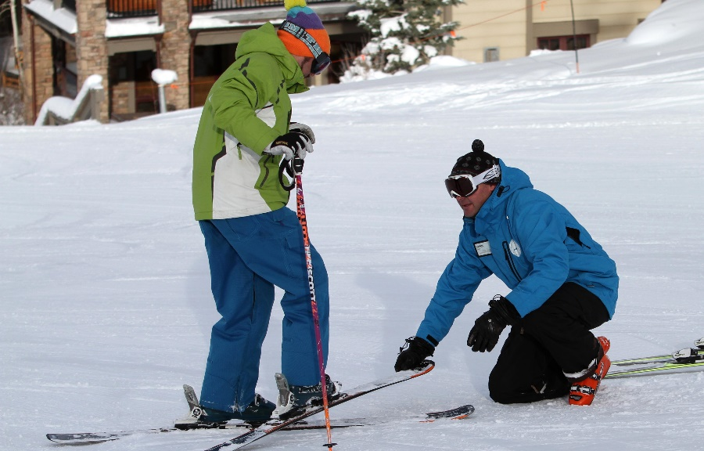

**Creativity and Adaptability**

Versatility is derived from knowing many different ways to teach the same thing, so that you are able to adapt to any given situation. For example, it is good that an instructor knows how to teach strong, fast turning of the legs to a student wishing to learn short radius turns for the 1st time. But knowing 10, 15 or even 50 ways to teach this faster leg turning will ultimately give them the versatility to adapt and teach a short turn to anyone, anywhere, anytime in any condition.

Having the access and creativity to multiple ways of teaching the same skill, movement or tactic allows an APSI instructor to vary their plan regardless of who they are working with or what situation the external environment throws at them. The APSI app is one tool our instructors utilize and have at   
their fingertips to build and learn this creative and versatile way of teaching. The resource

gives them access to information but also allows them to build their own progressions customized specifically to their guests needs and learning styles. It lets the instructor share these lesson plans with their students, colleagues and trainers allowing for an even greater distribution of knowledge and sharing of ideas. The App is designed for use before and after the lesson, not for the instructor to use half-way through to get some more ideas.

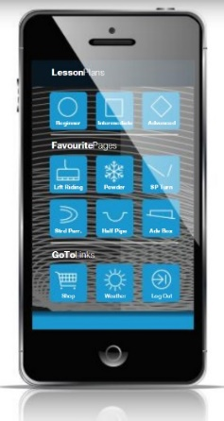 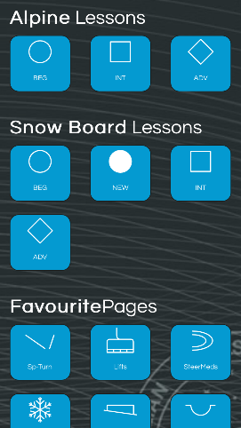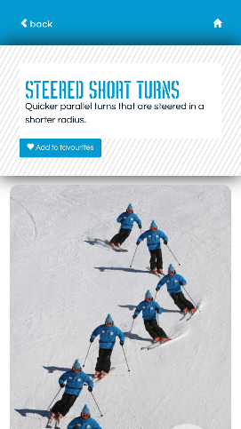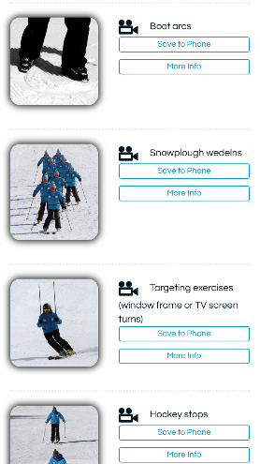

**What, Why and How**

These are 3 fundamental points that we try to touch on in all of the explanations, exercises or tasks that we do with our students. They don’t have to come out all at once but as long as they are touched on along the way. With practice this can be done simply and without long explanations.

*What*:

Explaining ‘what’ you are doing gives some context and structure to the lesson. Demonstrations or a title to the subject matter might be all that’s needed.

For example: “*We are going to use a Snowplough Wedelns to help us learn to turn our skis in a quicker rhythm on the snow to achieve a short turn.”*

*How*:

Explaining how they will achieve a certain mechanic, enables the guest to be a part of and aware of the learning process and actually gives them a road map to achieving their goal. Whether it be through verbal communication, a feeling, an exercise or task, if the student understands ‘how’ to turn their legs/skis faster with their instructor, the learning will continue long after the lesson is over. Through this education/awareness the guest can become their own teacher resulting in an even greater learning outcome towards their desired goal.

For example: “*We keep our skis in a small Snowplough position and then turn our feet and legs faster from side to side. You may feel these muscles to help turn them quicker……”*

*Why*:

This is definitely something the Australian guest demands from their instructor. They have a desire to know ‘why’ the movement or tactic will help them. By being part of the learning process, it helps to connect the dots for the student and by understanding this justification, the student can see a strategy for achieving their goal.

For example: “*The Snowplough Wedeln allows us to balance easily at slow speed while we are learning the quicker turning movements. It also gives us a wide stance/base of support, which help us quickly balance and edge from outside ski to outside ski*.”

To explain the importance of ‘Why’ an external analogy would be: If you went to see a dentist with the goal of relieving pain from a cranky tooth. What would happen if the dentist just started drilling without saying a word to you regarding the problem and why his intervention was going to help? Slightly disconcerting to the patient. Sure, you could trust their knowledge and everything may turn out ok. But it’s a more beneficial practice to bring the patient into the process by explaining why you want to drill that tooth and perform a root canal and what the results of this process will be for them. Not only does it help the student buy into the process but allows them to keep monitoring what they are doing and potentially how to avoid this problem again in the future. Success in teaching skiing can be achieved through a similar approach.



There are certainly a lot of principles that go into becoming a great snowsports teacher. We hope you enjoyed participating in the APSI on snow presentation to share at least these 3 key principles that we have found to be valuable in our teaching down under. Thank you to all of the other countries for sharing their knowledge and participating in the Interski Congress 2019, Bulgaria. We look forward to having you come visit us down in our Australian mountains soon.





Cheers,

APSI National Demonstration Team